ABET-aligned overall guidance for Final (Capstone)

1. Purpose of the Final Project
The Final Project (Capstone) is intended to:
- Integrate knowledge and skills acquired throughout the program
- Demonstrate the ability to design, implement, and evaluate computing-based solutions
- Address a real-world problem

2. Core Requirements (ABET-aligned)
Each project must include:

✔ A. Problem Definition
- Clearly defined real-world problem
- Motivation and relevance (industry, society, research)

✔ B. System Design
- Architecture (diagrams, components)
- Selection of technologies and tools
- Consideration of constraints (performance, security, usability)

✔ C. Implementation
- Use of at least one general-purpose programming language
- Functional system (not only theoretical work)
- Version control (e.g., Git)

✔ D. Application of Theory
- Algorithms and data structures
- Software engineering principles
- Use of appropriate computing concepts

✔ E. Use of Mathematics/Statistics
- Basic analysis (metrics, evaluation)
- If applicable: ML/statistical models

✔ F. Testing and Evaluation
- Functional testing
- Performance evaluation
- Use of metrics (accuracy, efficiency, usability)

✔ G. Documentation and Communication
- Written report (structured, academic)
- Oral presentation and demo (if applicable)
- Clear explanation of results

3. Recommended Project Structure (for students)
Students should follow this structure:
- Introduction
- Problem Statement
- Related Work (brief)
- System Design
- Methodology (algorithms, models)
- Implementation
- Results and Evaluation
- Discussion
- Conclusion and Future Work

4. Team vs Individual Projects
- ✔ Both formats acceptable
- ✔ Team projects must ensure:
  - clear role distribution
  - individual assessment

5. Expected Level (Undergraduate)
Projects should:
- Be moderate in complexity
- Focus on application, not research novelty
- Demonstrate integration of prior learning
- Result in a working system or prototype

6. Examples of Acceptable Outputs
- Web or mobile application
- AI/ML-based system
- Data analysis platform
- Cybersecurity tool
- IoT or embedded system
- Simulation system

7. Assessment Criteria (ABET-oriented)
Projects should be evaluated using rubrics covering:

✔ Technical Quality
- Correctness of implementation
- Use of appropriate algorithms

✔ Design and Architecture
- System structure and modularity

✔ Use of Theory
- Application of CS concepts

✔ Evaluation
- Testing, metrics, validation

✔ Communication
- Report quality
- Presentation

✔ Teamwork (if applicable)

8. What to AVOID (common ABET issues)
Pure literature review (no system)
Only theoretical work (no implementation)
Very small/simple projects
No evaluation or testing
No clear link to CS fundamentals

9. Key ABET Compliance Statement (you can reuse)
The Final Project requires students to integrate and apply knowledge of computer science theory, software development principles, and supporting mathematical concepts to design, implement, and evaluate a computing-based solution to a real-world problem.

10. Showing ompliance with Student outcome

1. Use of Computer Science Theory
Students must apply foundational CS concepts, such as:
- Algorithms (searching, sorting, optimization)
- Data structures (trees, graphs, hash tables)
- Complexity analysis (Big-O reasoning)
- Databases (normalization, query design)
- Networking / security principles (if relevant)
- AI/ML theory (if applicable)
NOT acceptable:
- Just using libraries blindly
- Pure UI/CRUD apps without theory

2. Software Development Fundamentals
Students must demonstrate engineering practices, not just programming:
- Software design (architecture, modularity)
- Version control (e.g., Git)
- Testing (unit/integration)
- Documentation (technical + user)
- Debugging and iteration
- Requirements → design → implementation flow
Process, not only final product

3. A Real “Computing-Based Solution”
The project must:
- Solve a defined problem
- Be more than a demo or tutorial
- Show end-to-end development

Topic options (examples)

1. Artificial Intelligence & Machine Learning

▪ General AI Systems
- AI-Based Recommendation System (movies, courses, books)
- Chatbot for University Services (using ChatGPT / Claude / Gemini)
- Intelligent Personal Study Assistant
- Fake News Detection System
- Resume Screening AI Tool

▪ Predictive Systems
- Student Dropout Prediction System
- Energy Consumption Forecasting Platform
- Sales Prediction Dashboard
- Traffic Congestion Prediction

▪ Natural Language Processing
- Sentiment Analysis for Social Media
- Automatic Essay Grading System
- Speech-to-Text System for Accessibility
- Multilingual Chatbot (including Georgian language)

2. Cybersecurity
- Intrusion Detection System (IDS)
- Phishing Website Detection Tool
- Password Strength Analyzer
- Secure File Sharing System
- Blockchain-Based Identity Verification
- Network Traffic Monitoring Dashboard
- Malware Detection using ML

3. Software Engineering / Web & Mobile Systems

▪ Platforms
- Learning Management System (LMS)
- Online Examination System with Proctoring
- Job Matching Platform
- Event Management System
- Smart Booking System (hotels, transport)

▪ Mobile Apps
- Personal Finance Tracker
- Health Monitoring App
- Habit Tracking System
- Smart Reminder with AI

4. Data Science & Big Data
- Data Visualization Platform for Public Data
- COVID / Health Data Analytics Dashboard
- Crime Data Analysis System
- Climate Data Analysis Tool
- Customer Behavior Analytics System

5. Computer Vision
- Real-Time Object Detection System
- Face Recognition Attendance System
- Emotion Detection from Facial Images
- Traffic Sign Recognition System
- AI-Based Surveillance System

6. IoT & Embedded Systems
- Smart Home Automation System (Arduino / Raspberry Pi)
- Smart Parking System
- Environmental Monitoring System
- IoT-Based Smart Agriculture System
- Smart Energy Meter

7. Robotics
- Line-Following Robot
- Autonomous Navigation Robot (e.g., TurtleBot 3)
- Obstacle Avoidance Robot
- Warehouse Delivery Robot

8. Cloud & Distributed Systems
- Cloud-Based File Storage System
- Microservices-Based Web Application
- Distributed Chat Application
- Load Balancing System
- Docker/Kubernetes Deployment Platform

9. Networking Systems
- Network Monitoring Tool
- Bandwidth Optimization System
- VPN Implementation
- Secure Communication Platform
- Software-Defined Network (SDN) Simulator

10. Human-Centered & Accessibility
- Navigation Assistant for Visually Impaired Users
- Voice-Controlled Computer Interface
- AI-Based Braille Translation Tool
- Audio-Based Learning Platform
- Accessible Mobile Learning App

11. Game Development
- Educational Game for Programming Learning
- AI-Based Game Opponent
- Strategy Game with Pathfinding Algorithms
- VR Learning Game (e.g., Meta Quest 3)

12. Algorithms & Simulation
- Pathfinding System (Shortest Path Algorithms)
- Scheduling Optimization System
- Epidemic Spread Simulation
- Traffic Simulation System
- Genetic Algorithm Optimization Tool

13. Interdisciplinary Projects
- AI for Medical Diagnosis Support
- Smart Disaster Management Platform
- Financial Risk Analysis System
- Smart City Monitoring System
- Agriculture Yield Prediction System

14. Education Technology (EdTech)
- Adaptive Learning System
- AI-Based Tutoring Platform
- Automated Quiz Generator
- Student Engagement Analytics Tool
- Virtual Classroom Platform

1. Data Science & AI Themes

1.1 Student Performance Prediction System
- Theory: regression, classification, feature engineering
- Solution: predicts student success/failure
- Evaluation: accuracy, F1-score

1.2 Fake News Detection System
- Theory: NLP, TF-IDF, classification algorithms
- Solution: classify news as fake/real
- Evaluation: precision/recall

1.3 Recommendation System
- Theory: collaborative filtering, matrix factorization
- Solution: recommend products/movies
- Evaluation: RMSE, ranking metrics

2. Cybersecurity Themes

2.1 Intrusion Detection System
- Theory: anomaly detection, classification
- Solution: detect malicious network traffic
- Evaluation: detection rate, false positives

2.2 Password Strength Analyzer
- Theory: entropy, hashing, pattern detection
- Solution: evaluate password security
- Evaluation: strength scoring

2.3 Phishing Detection Tool
- Theory: feature extraction, ML classification
- Solution: detect phishing URLs/emails
- Evaluation: accuracy

3. Software Engineering / Systems

3.1 Smart Task Management System
- Theory: scheduling algorithms, priority queues
- Solution: optimize task planning
- Evaluation: efficiency, response time

3.2 Distributed File Storage System
- Theory: distributed systems, replication
- Solution: fault-tolerant storage
- Evaluation: latency, reliability

3.3 Real-Time Chat System
- Theory: networking, concurrency
- Solution: messaging platform
- Evaluation: throughput, latency

4. Data Analysis Systems

4.1 COVID/Data Dashboard
- Theory: statistics, visualization
- Solution: interactive analytics dashboard
- Evaluation: usability + correctness

4.2 Market Analysis Tool
- Theory: clustering, correlation
- Solution: identify customer segments
- Evaluation: cluster quality

5. Advanced AI / Modern Topics

5.1 AI Chatbot (LLM-based or rule-based)
- Theory: NLP, dialogue systems
- Solution: conversational assistant
- Evaluation: response relevance

5.2 Computer Vision System
- Theory: CNNs, image processing
- Solution: object detection / classification
- Evaluation: accuracy

5.3 Speech Recognition or Emotion Detection
- Theory: signal processing, ML
- Solution: classify speech/emotion
- Evaluation: classification metrics

At the end oof the thesis, you must provide a Gantt Chart

What is a Gantt Chart?
A Gantt chart is a visual project management tool that represents project tasks along a timeline, showing their duration, sequence, and dependencies to support effective planning and execution.
A Gantt chart is a project management tool used to plan, schedule, and track tasks over time.
It shows:
- What tasks need to be done
- When they start and finish
- How long they take
- How tasks relate to each other
It is especially useful for Final (Capstone) projects to organize work clearly and demonstrate planning (important for ABET).

How a Gantt Chart Looks
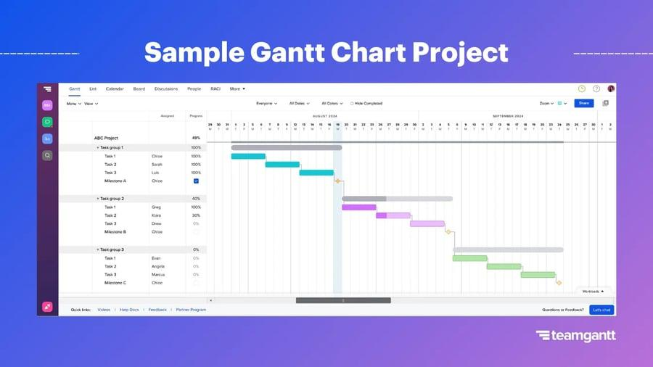
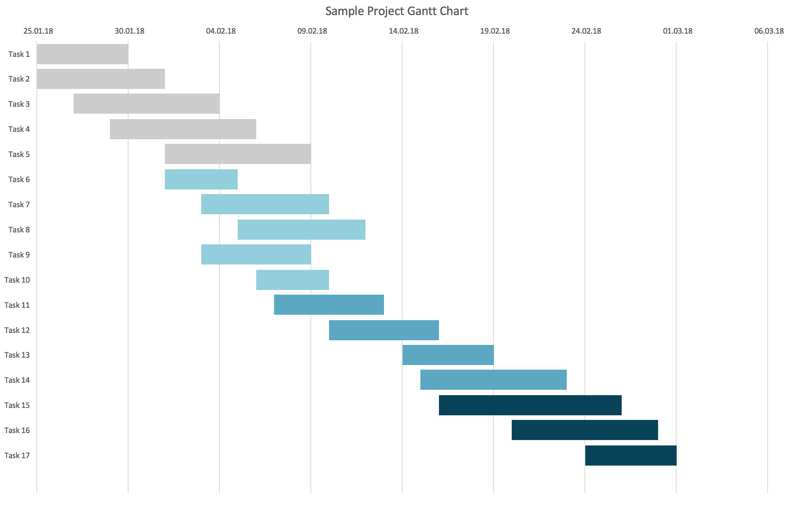
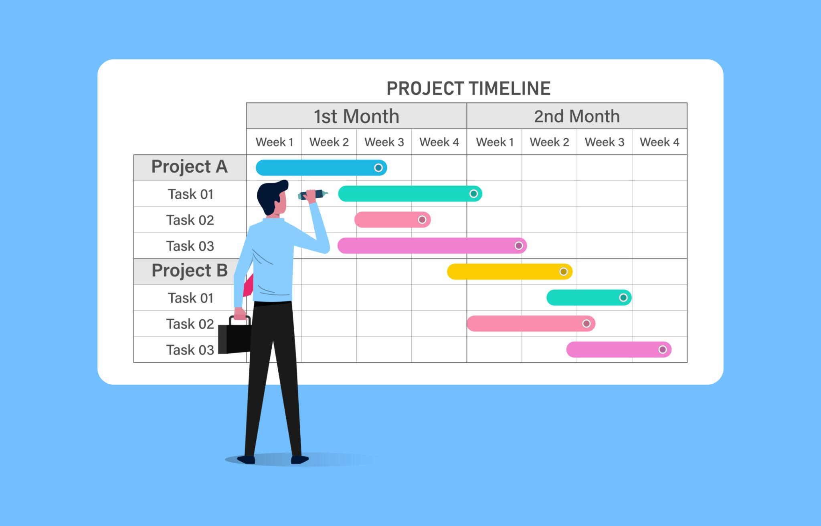
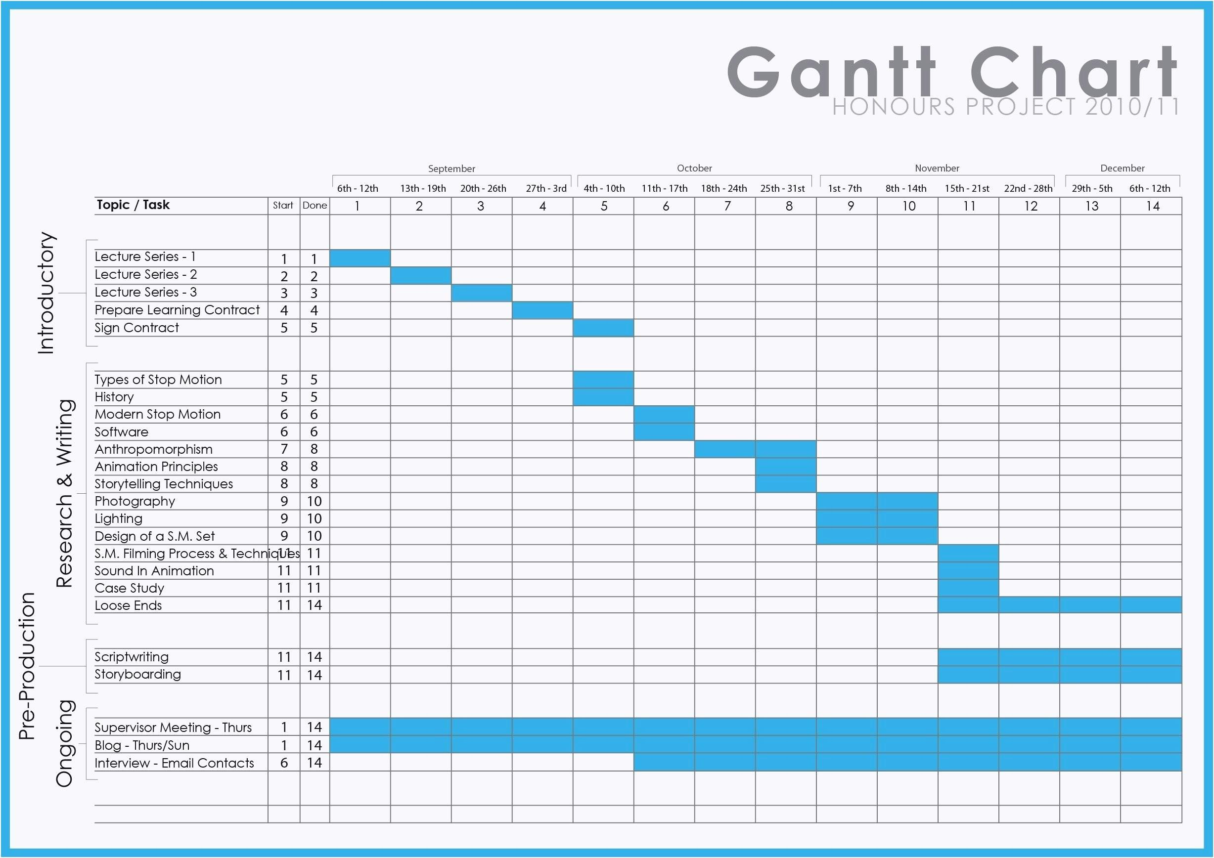
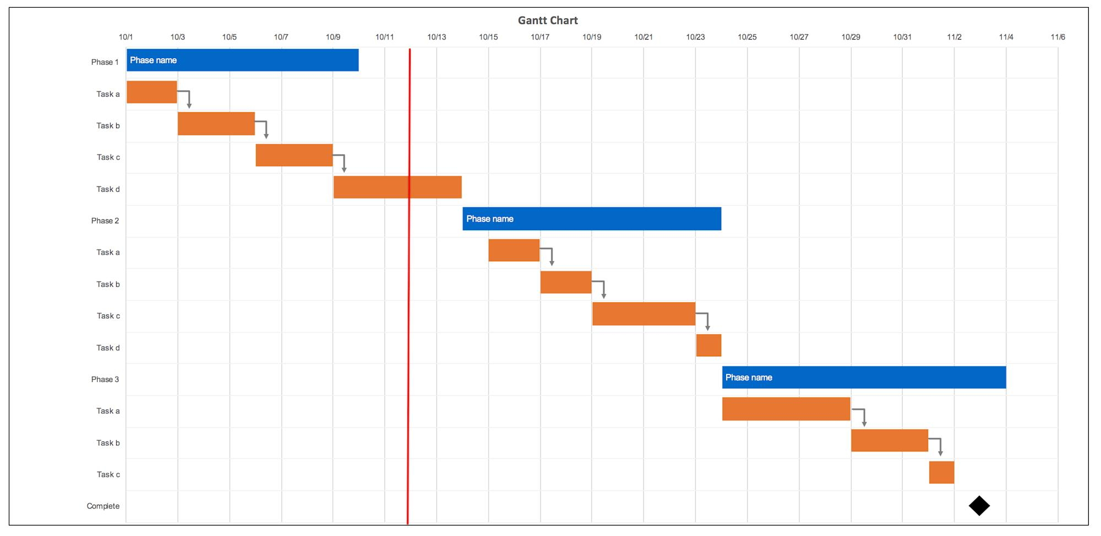
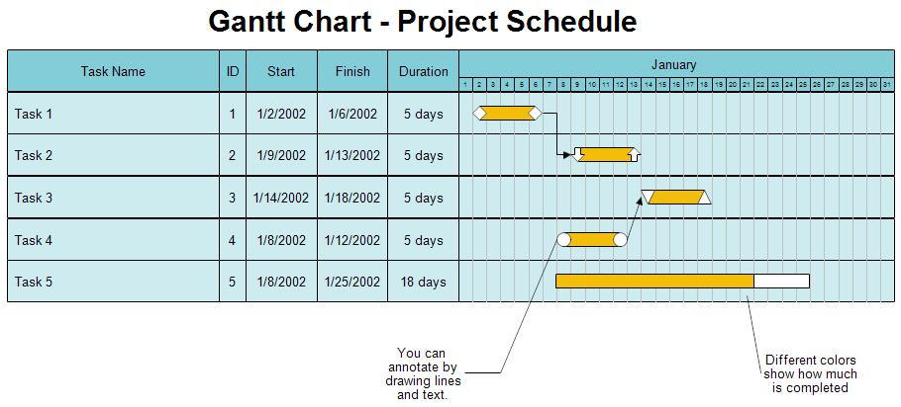
Typically:
- Left side → list of tasks
- Top → timeline (weeks/months)
- Bars → duration of each task

Key Elements

1. Tasks
List of activities:
- Literature review
- System design
- Implementation
- Testing
- Final report

2. Timeline
- Usually divided into weeks or months
- For undergraduate projects → often 10–16 weeks

3. Duration
- How long each task takes
- Represented by horizontal bars

4. Dependencies (optional but good)
- Some tasks depend on others
👉 Example:
- Cannot test before implementation

Example for a Final Project (12 Weeks)
Task | Week 1–2 | 3–4 | 5–6 | 7–8 | 9–10 | 11–12
Topic Selection | ███
Literature Review | ███ | ███
System Design |  | ███ | ███
Implementation |  |  | ███ | ███ | ███
Testing |  |  |  |  | ███ | ███
Report Writing |  |  |  |  | ███ | ███

Why it is important
For Final Projects & ABET:
✔ Shows planning and project management skills (SO5)
✔ Demonstrates structured development process
✔ Helps evaluators see project progression
✔ Supports continuous assessment

How students should use it
Students should:
- Create Gantt chart at the beginning
- Update it during the project
- Include it in:
  - project proposal
  - final report

Tools to create Gantt Charts
Students can use:
- Excel / Google Sheets
- Microsoft Project
- Trello (timeline view)
- Notion
- Asana

